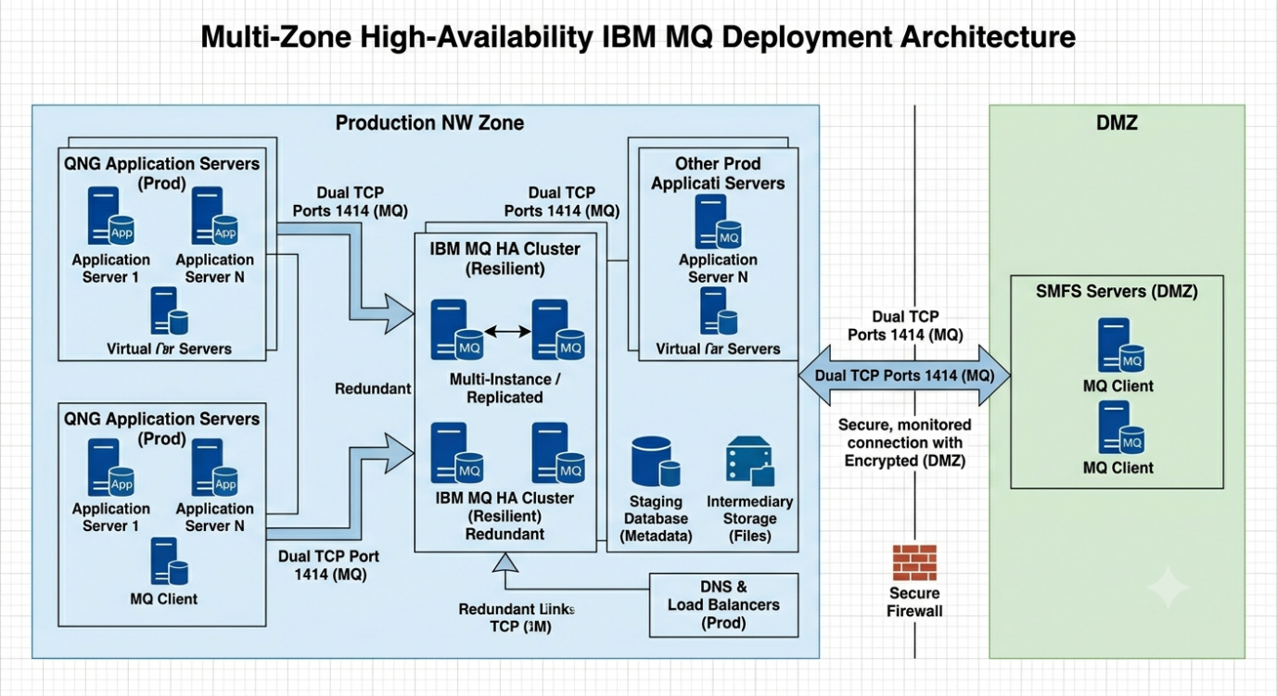
Proposed IBM MQ High Availability Architecture
Design Objectives
- Single common IBM MQ platform shared by:
  - SMFS application in DMZ
  - QNG application in Production
  - Additional Production applications using MQ Client
- High Availability (HA)
- Resilient across infrastructure failures
- Secure communication across network zones
- Centralized administration and monitoring

Target Architecture
┌──────────────────────────────────────────────────────────────────────┐
│ DMZ NETWORK │
└──────────────────────────────────────────────────────────────────────┘

+--------------------+
| SMFS Application |
| MQ Client |
+---------+----------+
|
| TLS 1.2/1.3
| MQ Channel (1414)
|
v

═══════════════════════ FIREWALL ═══════════════════════

^
|
| TLS 1.2/1.3
| MQ Channel (1414)
|

┌──────────────────────────────────────────────────────────────────────┐
│ PRODUCTION NETWORK │
└──────────────────────────────────────────────────────────────────────┘

+--------------------+ +---------------------+
| QNG Application | | Other Prod Apps |
| MQ Client | | MQ Clients |
+---------+----------+ +----------+----------+
| |
+-------------+--------------+
|
|
v

+-------------------------+
| Load Balancer / VIP |
| mq.company.com |
+------------+------------+
|
┌─────────┴─────────┐
│ │
▼ ▼

+------------------+ +------------------+
| IBM MQ Node-1 | | IBM MQ Node-2 |
| Active | | Standby |
| Queue Manager | | Queue Manager |
+--------+---------+ +--------+---------+
\ /
\ /
\ /
▼ ▼

+---------------------+
| Shared Storage |
| SAN / vSAN / NAS |
| MQ Logs & Data |
+---------------------+

|
|
▼

+---------------------+
| MQ Monitoring |
| MQ Explorer |
| Dynatrace/Splunk |
+---------------------+

Recommended IBM MQ HA Options
Option 1 (Preferred) – IBM MQ Native HA (RDQM)
IBM MQ Replicated Data Queue Manager (RDQM)
MQ Node-1 (Active)
MQ Node-2 (Synchronous Replica)
MQ Node-3 (Witness)
Benefits:
- No shared storage dependency
- Automatic failover
- Near-zero data loss
- IBM recommended architecture
- Simpler DR operations
Architecture:
+------------------+
| MQ Clients |
+--------+---------+
|
v
+-------------------+
| MQ VIP / DNS Alias|
+---------+---------+
|
┌───────────────────┼───────────────────┐
│ │ │
▼ ▼ ▼

+-------------+ +-------------+ +-------------+
| MQ Node-1 | | MQ Node-2 | | MQ Witness |
| Active | | Replica | | Quorum |
+-------------+ +-------------+ +-------------+
Recommended when:
- Virtualized infrastructure
- No SAN dependency desired
- MQ 9.x available

Option 2 – Traditional HA Cluster
Node-1 Active
Node-2 Passive

Shared SAN Storage
Benefits:
- Familiar architecture
- Easier migration from legacy MQ
Limitations:
- Shared storage becomes critical dependency
- SAN outage affects both nodes

Network Connectivity Requirements
Source | Destination | Port | Protocol | Purpose
SMFS (DMZ) | MQ VIP | 1414 | TCP/TLS | MQ Client Connection
QNG | MQ VIP | 1414 | TCP/TLS | MQ Client Connection
Other Prod Apps | MQ VIP | 1414 | TCP/TLS | MQ Client Connection
MQ Node-1 | MQ Node-2 | 1414 | TCP | MQ Replication
MQ Nodes | LDAP/AD | 389/636 | TCP | Authentication
MQ Nodes | NTP | 123 | UDP | Time Sync
Monitoring | MQ Nodes | 9157 | TCP | Metrics (Optional)

Security Architecture
DMZ SMFS
│
│ TLS Encrypted MQ Channel
▼
Firewall
│
▼
MQ VIP
│
▼
IBM MQ Cluster
Controls:
- TLS 1.2/1.3 only
- Mutual certificate authentication
- Separate MQ channels:
  - CHL.SMFS.DMZ
  - CHL.QNG.PROD
  - CHL.APP.PROD
- Channel authentication records (CHLAUTH)
- Firewall allow-listing
- Queue-level authorization

Queue Design
QM.COMMON.PROD

├── Q.SMFS.IN
├── Q.SMFS.OUT
│
├── Q.QNG.IN
├── Q.QNG.OUT
│
├── Q.APP.IN
├── Q.APP.OUT
│
└── SYSTEM.DEAD.LETTER.QUEUE

Enterprise Recommendation
For a new deployment, use:
IBM MQ RDQM (3-node architecture) in the Production zone with:
- DNS alias or VIP (mq.company.com)
- TLS-secured MQ client channels
- Separate application channels and queue permissions
- Monitoring via Prometheus/Grafana or Splunk/Dynatrace
- Optional secondary DR MQ cluster in another datacenter
This provides the highest availability, automatic failover, and eliminates the shared-storage single point of failure while allowing both DMZ and Production applications to consume the same resilient IBM MQ service.

